***Section* 1.5 – Length of Curves**

**Length of a curve **

We assume that *f* has a continuous derivative at every point of [*a, b*]. Such function is called ***smooth***, and its graph is a ***smooth curve*** because it doesn’t have any breaks, corners, or cusps.

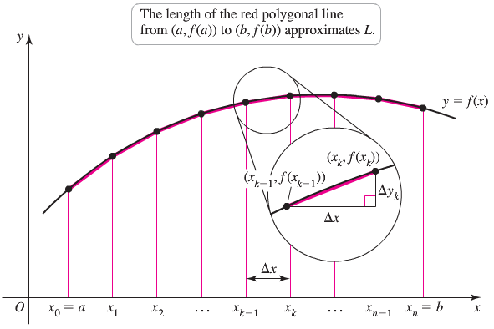

***Definition***

If  is continuous on [*a, b*], then the length (arc length) of the curve  from the point  to the point  is the value of the integral



***Example***

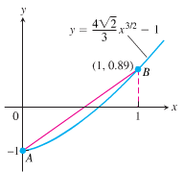Find the length of the curve 

***Solution***

 

 



 















***Example***

Find the length of the graph of 

***Solution***



1.  ***√***
2.  ***√***









***Discontinuities* in **

**Formula for the length of **

If  is continuous on [*c, d*], the length of the curve  from the point  to the point  is the value of the integral



***Example***

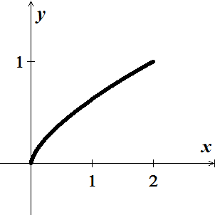Find the length of the curve  from *x* = 0 to *x* = 2.

***Solution***



  (***CP***)

 ***Raised both sides to the power* 3/2**



 















***Example***

Find the arc length function for the curve  on the interval 

***Solution***

|  |  |
| --- | --- |
|  |  |

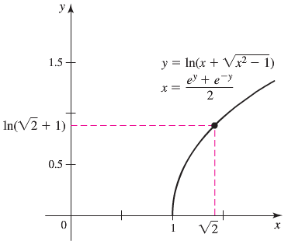









|  |  |
| --- | --- |
|  | ***OR***     1. ***√*** 2. ***√*** |

**The differential Formula for Arc length**

If  and if  is continuous on [*a, b*], then by the Fundamental Theorem of Calculus, we can define a new function









***Example***

Find the arc length function for the curve  taking  as the starting point

***Solution***

















***Exercises Section* 1.5 – Length of Curves**

Find the length of the curve of

|  |  |
| --- | --- |
| 1. from *x* = 0 to *x* = 3 2. from *x* = 0 to *x* = 4 3. from *y* = 1 to *y* = 9 4. from *y* = 2 to *y* = 3 |  |

1. Find the length of the curve 
2. Find the length of the curve 
3. Find the length of the curve . Check your answer by finding the length of the segment as the hypotenuse of a right triangle.
4. The profile of the cables on a suspension bridge may be modeled by a parabola. The central span of the Golden Gate Bridge is 1280 *m* long and 152 *m* high. The parabola  gives a good fit to the shape of the cables, where , and *x* and *y* are measured in meters. Approximate the length of the cables that stretch between the tops of the two towers.

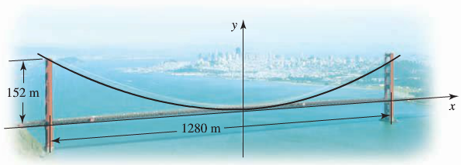

1. Find a curve through the origin in the *xy*-plane whose length from *x* = 0 to *x* = 1 is



1. Confirm that the circumference of a circle of radius *a* is 
2. Electrical wires suspended between two towers form a caternary modeled by the equation

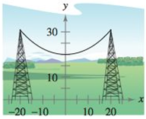



Where *x* and *y* are measured in meters. The towers are 40 meters apart. Find the length of the suspended cable.

1. A barn is 100 feet long and 40 feet wide. A cross section of the roof is the inverted caternary . Find the number of square feet of roofing on the barn.

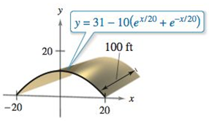

1. A cable for a suspension bridge has the shape of a parabola with equation . Let *h* represent the height of the cable from it lowest point to its highest point and let  represent the total span of the bridge.

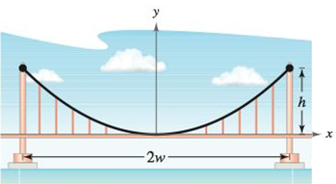

Show that the length *C* of the cable is given by 

1. Find the total length of the graph of the astroid 
2. Find the arc length from  clockwise to  along the circle 
3. Find the arc length from  clockwise to  along the circle . Show that the result is one-fourth the circumference of the circle.
4.  between  and  that



Use any means to approximate the value of *b* for which the curve has length 2.